**THE PEARL EXAMINATIONS 2024**

**TERM II QUALITY ASSURANCE**

**TOP CLASS: (5 – 6 YEARS)**

**LEARNING AREA 4: MATHEMATICAL CONCEPTS**

**My name is: …………………………………..………………………….**

**My School is: ……………………………..………….…………………..**

**I am in: ……………………….…………..…………………………………………..**

1. **Write numbers 1 – 20**

I ______ ______ ______ 5 _____ ______ ______ ______ ______ II ______ I3 ______ ______ ______ ______ I8, I9 ______

1. **Draw balls on the string**

**= 8**

**= 10**

**= 4**

**= 6**

1. **Count and write**

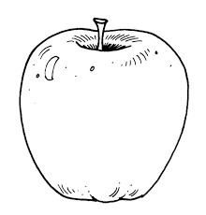

**=**



**=**

**=**

**=**

1. **Write the numbers which comes between.**

4 _____ 6 9______11

3______5 18_____20 10_____12

1. **Which number comes after**

**5______ 18 ______ 10 ______ 16 _____**

**8 _____ 11 ______ 6 ______**

1. **Circle the right number**



**12, 13, 14 8, 6, 7**



**10, 7, 9 13, 17, 14**

1. **Match pictures to numbers**



**7**

**5**

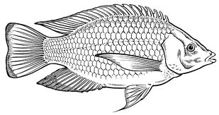

**4**

**2**



**6**

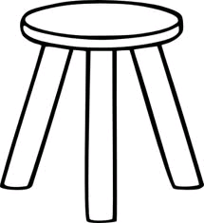

**END**